PONY PALS WREKIN
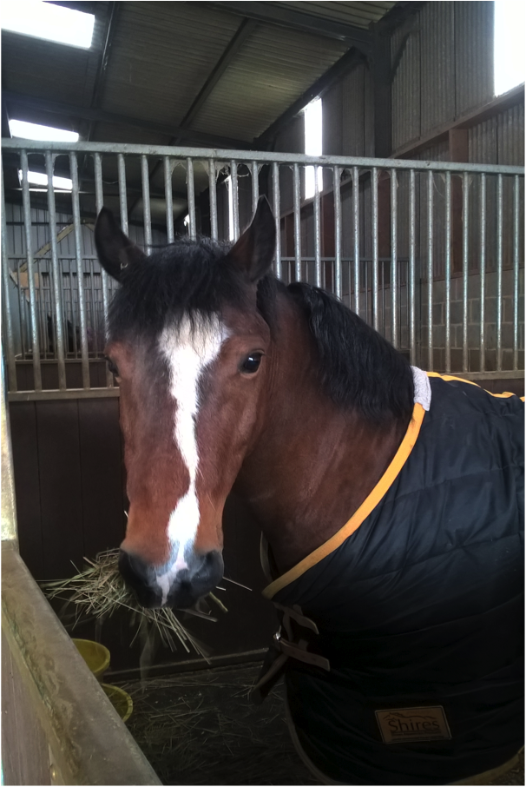
BOOKING FORM
Schools

Child’s name: _______________________________________________
Date of Birth: _______________________________________________
Height: _______________________________________________
Weight: _______________________________________________
Address: _______________________________________________
_______________________________________________
_______________________________________________
Parent/Carer name: _______________________________________________
Number: _______________________________________________
Email: _______________________________________________
School Name: _______________________________________________
Address: _______________________________________________
_______________________________________________
_______________________________________________
Contact Number: _______________________________________________
Email: _______________________________________________

Family Info: (Siblings, parents, key carers, names and any key details, this will be used to assist developing relationships with the child).
_______________________________________________
_______________________________________________
_______________________________________________

Child’s Diagnosis: _______________________________________________
Any other medical problems, Inc. allergies?
_______________________________________________
How does the child communicate: _______________________________________________

Would you describe the child as high or low energy?
_______________________________________________
Does the child have any violent behaviours?
_______________________________________________
What school year is the child?
_______________________________________________
Are they learning an age related syllabus?
_______________________________________________
What does the child enjoy?
_______________________________________________
_______________________________________________
_______________________________________________
What does the child dislike?
_______________________________________________
_______________________________________________
_______________________________________________
Please tick which of the following the child likes to play with:

Water [ ]
Sand [ ]
Balls [ ]
Animals [ ]
Trucks/Cars [ ]
Trains [ ]
Disney characters [ ]
Rocks/Sticks [ ]
Dolls [ ]
None of the above [ ]

If selected none, please give information on the things the child does find interesting;
______________________________________________
______________________________________________
______________________________________________

Does the child stim? Yes [ ]
No [ ]
If yes, how? ______________________________________________
______________________________________________

What is the child afraid of?
______________________________________________
______________________________________________
______________________________________________
Has the child ridden before? If so when, how, and what was their reaction to ponies?
______________________________________________
______________________________________________
______________________________________________

What is the aim from the Pony Pals session? Tick all that apply,
Sensory [ ]
Calming [ ]
Play [ ]
Education [ ]
Social [ ]
Please give more information about the aims for this child;
_______________________________________________
_______________________________________________
_______________________________________________
_______________________________________________
_______________________________________________
_______________________________________________
_______________________________________________
_______________________________________________
_______________________________________________
_______________________________________________
_______________________________________________
_______________________________________________
_______________________________________________
_______________________________________________

Sessions are offered subject to availability. Session costs are;
[ ] ½ hour - £29 per child per session
[ ] ¾ hour - £39 per child per session
[ ] 1 hour - £49 per child per session
[ ] 1 ½ hours - £79 per child per session

Equine sessions are on a one-to-one basis. If a number of sessions are booked as a block
the school can bring all the children booked in together, and use the site for school lead
work while individual equine sessions take place. Schools can through discussion be
creative how they utilise the hour long sessions, for example, depending on the needs
of the children, then shorter sessions such as 20 minutes per child can then
accommodate 3 children per one hour session.

As an alternative schools can book Movement Method sessions. Movement sessions can
accommodate potentially a number of children per session, depending on the needs of
the children. Staffing requirements by the school for these sessions will also depend on
the needs of the children.

Schools are also welcome to use the pony pals site for an additional hour for school
lead camp cooking sessions at the end of block morning bookings. This is at an
additional charge of £15 for the hours use of the site, not a per child charge.

Most sessions offered are during term time school hours. School holiday session are
available on a sporadic basis. Additionally the site can be hired by schools to run their
own school lead sessions during holiday periods. This includes overnight hires for
camping experiences. Please contact for further details.

Please tick below which sessions are required.

Equine session 1 hour @ £45 [ ]
Equine session ½ session @ £25 [ ]
Movement session 1 hour @ £45 [ ]
Movement session ½ hour @ £25 [ ]
Camp cooking session @ £15/group [ ]

Please tick to indicate agreement to the below:
Equine/movement sessions are £55 per session per child. When booked as block booking.
[ ]
If bringing individual children then sessions will be run as a private session and the private charge will apply, £70 per session, these sessions are longer, one and a half hours.
[ ]
Children from the same school may remain on the site and use the none equine facilities for school lead sessions while other children from the same school are taking equine sessions. This will be at no additional charge. Children must be supervised by the school at all times during these periods.
[ ]
Schools cooking site hire is £20 per session for the use of the site for the hour.
[ ]
Invoices will be issued monthly. Payment to be made within 30 days.
[ ]
Schools are responsible for the child at all times, and must provide at least one adult per child attending the site. This ratio may be requested to be increased depending on the needs of the child. The adult/s MUST remain with the child at ALL times, and be prepared to walk with the horse and child.
[ ]
The site by its nature of it being a natural environment contains numerous potential dangers, for example water in the form of the stream. The school is responsible for the care and safety of the child at all times.
[ ]
The child and the adult/s accompanying must wear suitable clothing and footwear whilst on the site.
[ ]
Hats are provided and must be worn when mounted on a pony, or in the carriage, or when around any equines. This applies to all children, and adults.
[ ]
Please give at least 48 hours’ notice of a session being cancelled, otherwise full price will be charged.
[ ]
Pony Pals reserves the right to cancel sessions without notice, however unless in exceptional circumstances 24 hours’ notice will be given.
[ ]
No pets to be brought to the site.
[ ]
No smoking on site.
[ ]
All adults and children visiting the site must stay within the Pony Pals site unless invited elsewhere by the proprietor.
[ ]
Food and drink may be cooked at the site but must be provided by the school and cooked by the school.
[ ]
All accidents and incidents taking place on the site, will be reported to the proprietor, and accident forms completed prior to leaving the site.
[ ]
Cancellation of a reserved session, there must be half a terms notice in writing.
[ ]
For schools sessions may be swapped to accommodate other children from the same school, with prior notice and a completed booking form per child attending, but if a school wishes to permanently cancel a reserved session half a terms notice will be required.
[ ]
Vehicles are parked at owners own risk.
[ ]
Fires only to be lit in the designated fire pit/BBQ.

[ ]

Any equipment stored on site by the school taking up block bookings is left at their own risk.
[ ]

Signed: ___________________________________
Print full name: ___________________________________
Position held: ___________________________________
Date: ___________________________________

